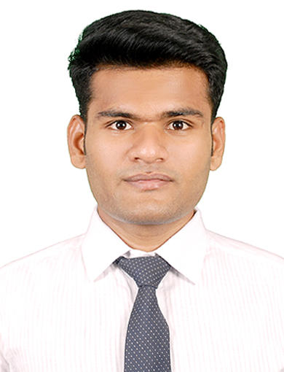
Name | PAVAN KUMAR
Nationality | Indian
Father’sName | ARVIND CHAVAN
Address | Near infant medical SG palya road Koramangala Bangalore
D.O.B | 29/10/2000
Height | 175 cm
Weight | 63

CareerObjective:
To adapt to the working environment and deliver my expertise in the innovative hospitality skills, while maintaining the integrity and work ethics, thereby keeping up the reputation of the organisation.

EducationalQualification:

S.no | EducationalQualification | Name of the School /Institute | From(dd//mm/yyyy) | To(dd/mm/yyyy)
1 | SSLC | MINI ROSE PUBLIC SCHOOL | 2015 | 2016
2 | PUC | RNS PRE UNIVERSITY | 2016 | 2018
3 | BSC | SS MARGOL COLLEGE | 2019 | 2021
4 | DIPLOMA | FRANKFINN INSTITUTE | 2021 | 2022

OtherAchievements
- Diploma in Aviation, Hospitality, Travel, and customer Service from Frankfinn Air hostess institute(20212022)
- AMEDUS Software Certificate

Skills:
  - Good Communication And Motivational Skills.
  - Friendly And Helping Attitude With Passion For Customer Service.
  - Clean, Professional, And Pleasing Appearance.
  - Willingness To Take-up Different Tasks And Fulfill Responsibility.
  - Ability To Multi task At Any Given Situation.

Experience:Currently working in kempegowda international airport

Languages known:

language | Read | Write | Speak
HINDI | ✔ | ✔ | ✔
ENGLISH | ✔ | ✔ | ✔
KANNADA | ✔ | ✔ | ✔

I here by declare that all the above information is correct and best to my knowledge

Name:PAVAN KUMAR

Email:pavanchavan725@gmail.com

Contact no:8123606247

Date:11/10/22

