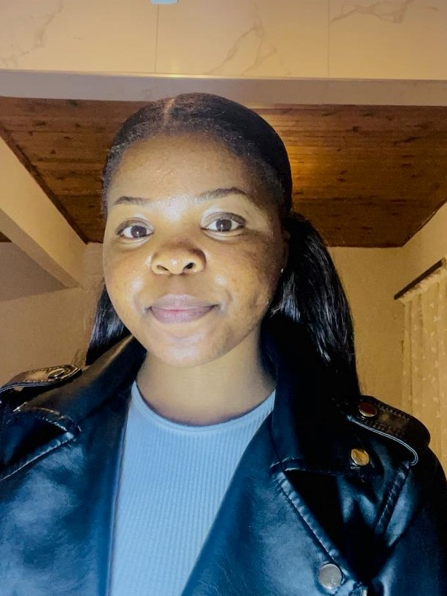
Sibahle
Kamva
Bovungana

Objective
- I am a young female looking for an opportunity to explore, get experience and contribute to any workforce. Some of my traits are that I am an interactive person who is not afraid of hard work, I can easily adapt to new environments. I am an adventurous person who is always willing to learn and apply myself. I have a customer service minded approach, work well under pressure and can diligently work while contributing adequately to any team.

Reference

- Name: Mrs. Akhona Madonsela
- Role: General Manager – Legogote Timbers
- Contact number: +27 (0)87 654 7584
- Email address: akhona.madonsela@legogotetimbers.co.za

- Name: Miss Yolanda Mngatiwa
- Role: Controller - Transnet
- Contact number: +27 (0)65 902 1543
- Email address: Yolandabovungana8@gmail.com

- Name: Ms. Zandile Bovungana
- Role: Educator - Freedom Park Secondary School
- Contact number: +27 (0)78 080 3150
- Email address: Zandilebovungana05@gmail.com

Education
Senior Certificate – Diploma in Commerce 2023

EXPERIENCE
Company: Legogote Timbers
Period: Nov 2023 – Feb 2024
Title: Administrate Assistant
Role responsibilities:
- Professionally answering and Redirecting Calls
- Matching invoices to delivery notes
- Data capturing
- Assist customers with invoicing queries
Reason for leaving: Short term contract expired

Skills
- Effective communicator
- Great adaptability skill
- Self motivated
- Good time management skills
- Team player

Personal information
- Gender: Female
- Nationality: South African
- Location: Doha Qatar
- Date of birth: 04 May 2005
- Bovunganasibahle@gmail.com
- + 947 66041421

Language
- English
- isiXhosa
- IsiZulu

